**DAILY ONLINE ACTIVITIES SUMMARY**

|  |  |  |  |  |  |  |  |  |
| --- | --- | --- | --- | --- | --- | --- | --- | --- |
| **Date:** | **6-06-2020** | | | | | **Name:** | **Javahar.S.Goutham** | |
| **Sem & Sec** | **7th B sec** | | | | | **USN:** | **4AL16CS132** | |
| **Online Test Summary** | | | | | | | | |
| **Subject** | | **Internet of things** | | | | | | |
| **Max. Marks** | | **30** | | **Score** | | | **30** | |
| **Certification Course Summary** | | | | | | | | |
| **Course** | **Introduction to ethical hacking(completed)**  **RPA** | | | | | | | |
| **Certificate Provider** | | | **Great Learning**  **Guvi** | | **Duration** | | | **9hrs** |
| **Coding Challenges** | | | | | | | | |
| **Problem Statement**: 1.Write a program in C to rotate an array by N positions.  **2.** Write a Python program to perform Cyclic Redundancy Check. | | | | | | | | |
| **Status: YES, Completed all Programs.** | | | | | | | | |
| **Uploaded the report in Github** | | | | | **YES** | | | |
| **If yes Repository name** | | | | | <https://github.com/alvas-education-foundation/Dhanya-bhat-4AL17CS027> | | | |

Online Test Details: (Attach the snapshot and briefly write the report for the same)

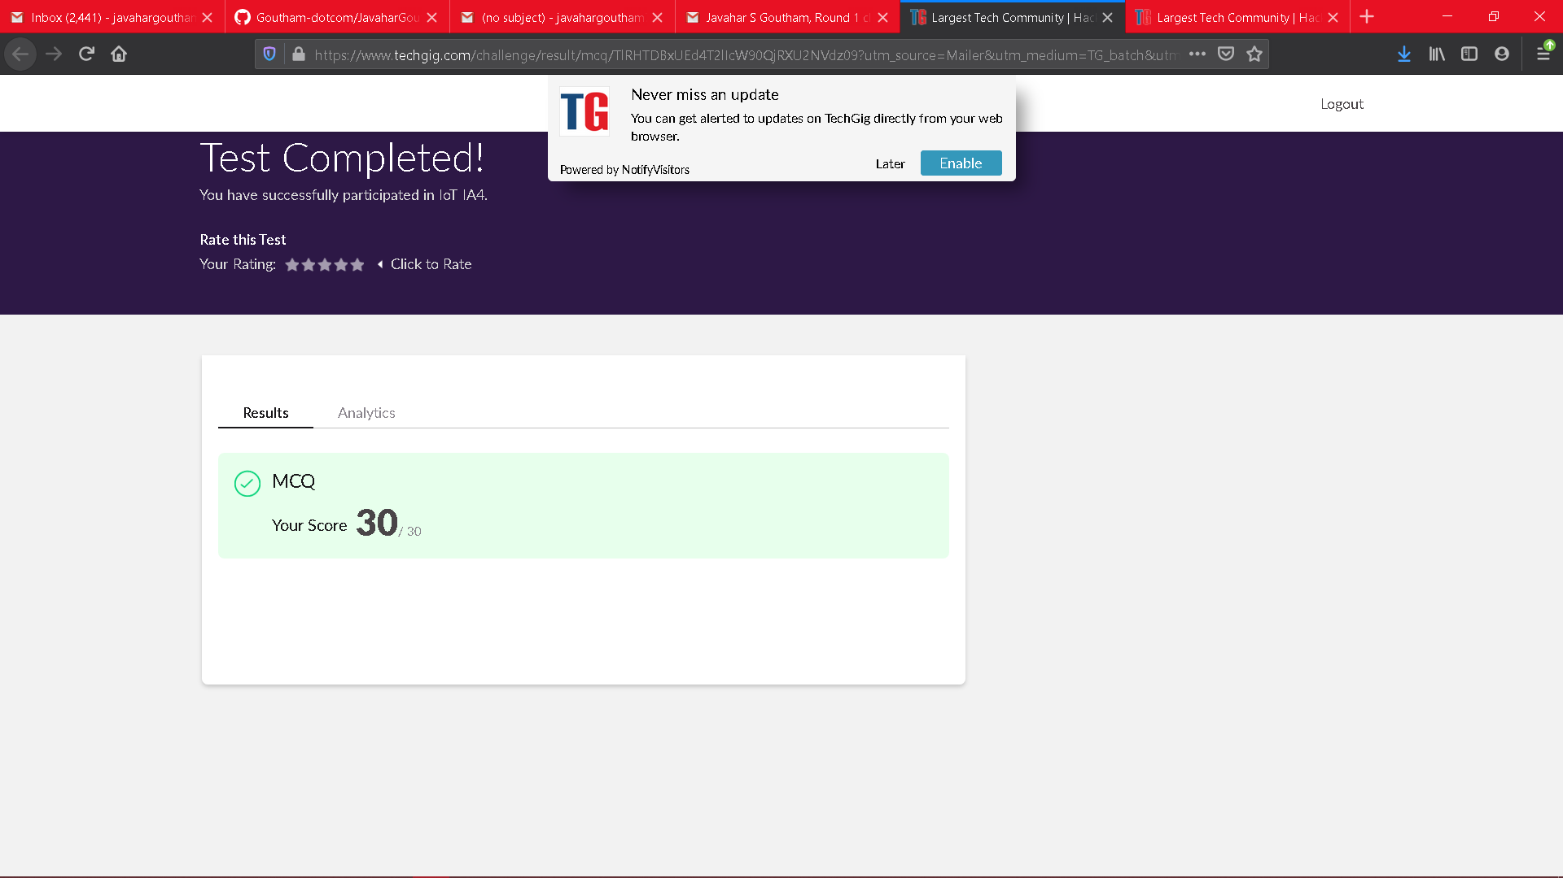

Scored 30 out of 30 in IOT test

Certification Course Details: (Attach the snapshot and briefly write the report for the same)

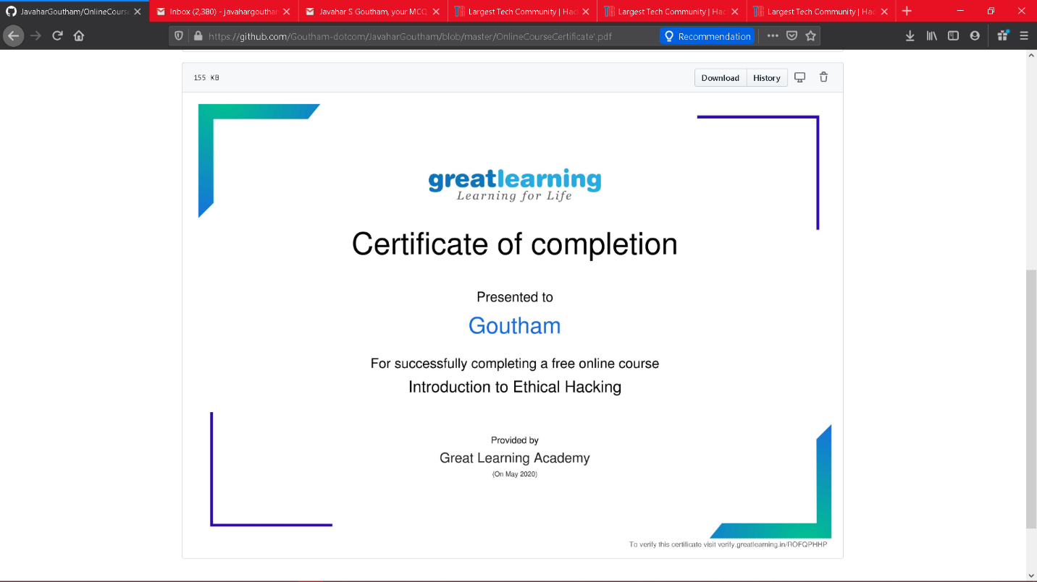

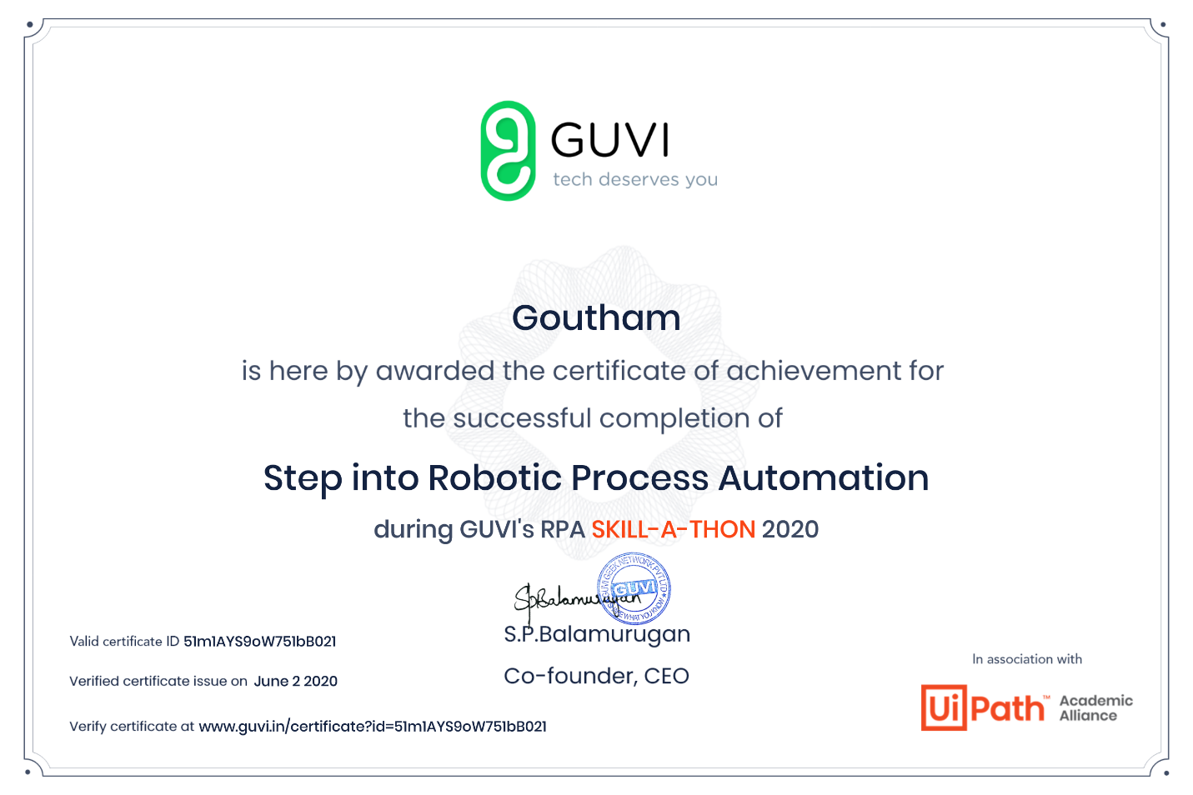

Coding Challenges Details: (Attach the snapshot and briefly write the report for the same)

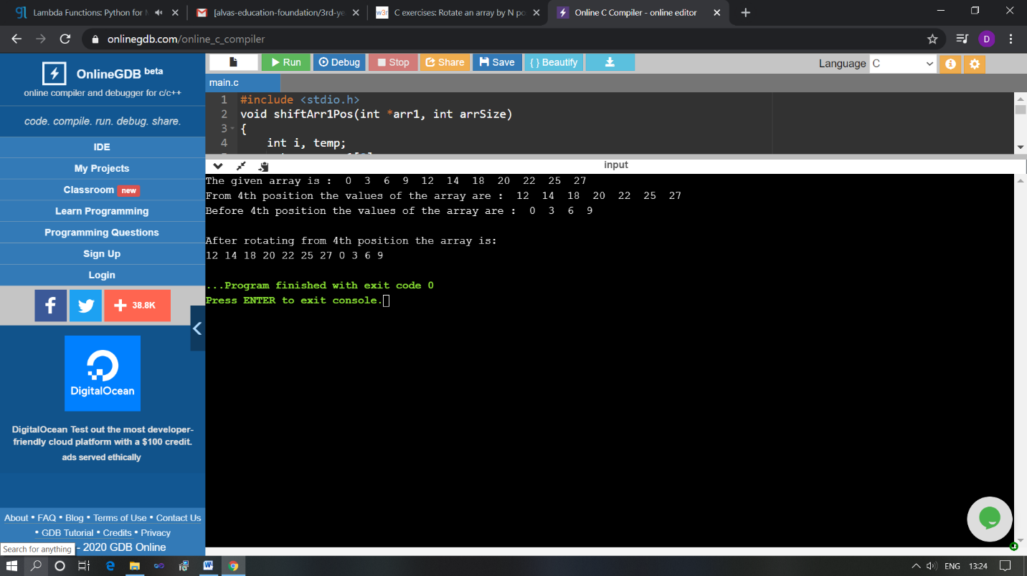

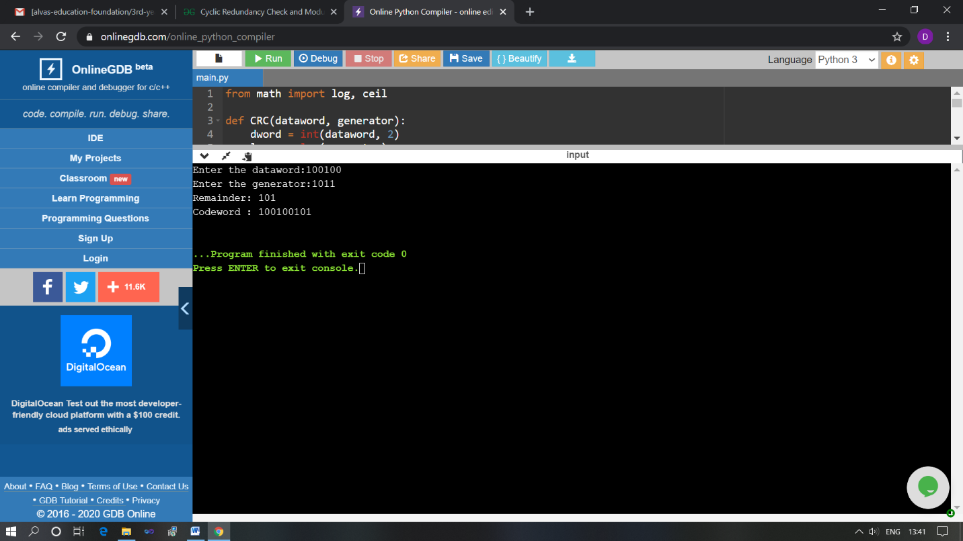

The above Programs were written and executed and the output of the same is displayed above. The code for those 2 programs have been uploaded to the github repository and the link to the same is provided on the form.